Las Palmas – Apache, Tomcat y OpenCms para acceder a través del puerto 80

Tabla de contenido

Introducción - 2 -

Tomcat - 2 -

Apache - 2 -

Módulos - 2 -

Virtual Host - 2 -

OpenCms - 4 -

Configurar plantillas - 5 -

Configurar Apache para que lea los VH generados: - 8 -

Permisos - 9 -

# Introducción

Para configurar el acceso a opencms a través de su dominio por el puerto 80 es necesario configurar la comunicación entre Apache, Tomcat y OpenCms como explicamos a continuación.

# Tomcat

1. Editamos el fichero **context.xml**

sudo nano $tomcat/conf/context.xml

1. Agregamos la propiedad **sessionCookiePath**

<Context sessionCookiePath="/">

# Apache

1. Editamos el fichero de configuración de apache **httpd.conf**

sudo nano $httpd/conf/httpd.conf

1. Añadiendo la variable ServerName con el dominio o la IP

…

ServerName dev.laspalmas[1]

## Módulos

Para que funcione correctamente es necesario tener instalados los siguientes módulos: **mod_jk, mod_proxy, mod_proxy_http, mod_rewrite y mod_deflate.**

## Virtual Host

Es necesario configurar un virtual host para cada site y subdominio.

1. Creamos VH:

<VirtualHost *:80>

DocumentRoot "/opt/apache-tomcat-7.0.72/webapps/opencms/"

ServerName dev.laspalmas[2]

ServerAdmin webmaster@laspalmas.com[3]

# Allow accessing the document root directory

<Directory /opt/apache-tomcat-7.0.72/webapps/opencms/resources>

Options FollowSymlinks

AllowOverride All

Order allow,deny

Allow from all

Require all granted

</Directory>

<Directory /opt/apache-tomcat-7.0.72/webapps/opencms/export>

Options FollowSymlinks

AllowOverride All

Order allow,deny

Allow from all

Require all granted

</Directory>

# Logging

LogFormat "%h %l %u %t \"%r\" %>s %b" common

CustomLog /var/log/httpd/access_mv80.sagadev.log[4] common

ErrorLog /var/log/httpd/error_mv80.sagadev.log[5]

LogLevel alert rewrite:trace1

# Do not forward the request if the requested URI is located in the resources folder or is static content

SetEnvIfNoCase Request_URI ^/opencms/resources/.*$ no-jk

SetEnvIfNoCase Request_URI ^/export/.*$ no-jk

# Turn rewriting on and define the rules

RewriteEngine On

# Deny access to php files in order to prevent reading resources

RewriteCond %{REQUEST_FILENAME} (.+)\.php(.*)

RewriteRule (.*) / [F]

# If the requested URI is NOT located in the resources folder and is not static:

# Prepend an /opencms/opencms to everything that does not already starts with it

# and force the result to be handled by the next URI-handler ([PT]) (JkMount in this case)

RewriteCond %{REQUEST_URI} !^/opencms/workplace.*$

RewriteCond %{REQUEST_URI} !^/opencms/VAADIN/.*$

RewriteCond %{REQUEST_URI} !^/opencms/resources/.*$

RewriteCond %{REQUEST_URI} !^/export/.*

RewriteRule !^/opencms/opencms/(.*)$ /opencms/opencms%{REQUEST_URI} [PT]

# These are the settings for static export. If the requested resource is not already

# statically exported create a new request to the opencms404 handler. This has to be

# a new request, because the current would not get through mod_jk because of the "no-jk".

RewriteCond %{REQUEST_URI} ^/export/.*$

RewriteCond "%{DOCUMENT_ROOT}%{REQUEST_FILENAME}" !-f

RewriteCond "%{DOCUMENT_ROOT}%{REQUEST_FILENAME}/index_export.html" !-f

RewriteRule .* http://localhost:8080/opencms/opencms/handle404?exporturi=%{REQUEST_URI}&%{QUERY_STRING} [P]

# If the request starts with /opencms/resources, substitute the /opencms10 prefix

RewriteCond %{REQUEST_URI} ^/opencms/resources/.*$

RewriteRule ^/opencms/(.*)$ /$1

JkMount /* ocms

</VirtualHost>

# OpenCms

1. Editar el fichero $TOMCAT\webapps\opencms\WEB-INF\config\**opencms-system.xml configurando el site default** dev.laspalmas

<sites>

<workplace-server>http://dev.laspalmas[6]</workplace-server>

<default-uri>/sites/default/</default-uri>

<shared-folder>/shared/</shared-folder>

<site server="http://lpamar.laspalmasgc.es[7]" uri="/sites/lpamar/" tit le="LPAmar" position="1.7014117E38" webserver="true"/>

…

</sites>

1. Editar el fichero $TOMCAT$\webapps\opencms\WEB-INF\config\**opencms-importexport.xml** y modificar la exportación a disco y el prefijo de la URL:

<rendersettings>

<rfs-prefix>export</rfs-prefix>

<vfs-prefix></vfs-prefix>

</rendersettings>

## Configurar plantillas

Para que al crear un Nuevo site opencms nos genere el virtual host podemos:

1. Modificar el fichero /opt/apache-tomcat-7.0.72/webapps/opencms/WEB-INF/server-scripts/vhost.template:

<VirtualHost *:80>

DocumentRoot "$DOCUMENT_ROOT$"

ServerName $SERVER_NAME_WITH_PORT$

$ALIAS_DIRECTIVE$ $SERVER_ALIASES$

ServerAdmin webmaster@$SERVER_NAME_WITH_PORT$

# Allow accessing the document root directory

<Directory $DOCUMENT_ROOT$/resources>

Options FollowSymlinks

AllowOverride All

Order allow,deny

Allow from all

Require all granted

</Directory>

<Directory $DOCUMENT_ROOT$/export>

Options FollowSymlinks

AllowOverride All

Order allow,deny

Allow from all

Require all granted

</Directory>

# Logging

LogFormat "%h %l %u %t \"%r\" %>s %b" common

CustomLog $LOGGING_DIRECTORY$access_$CONFIG_FILENAME$.log common

ErrorLog $LOGGING_DIRECTORY$error_$CONFIG_FILENAME$.log

LogLevel alert rewrite:trace1

# Do not forward the request if the requested URI is located in the resources folder or is static content

SetEnvIfNoCase Request_URI ^$CONTEXT_PATH$/resources/.*\$ no-jk

SetEnvIfNoCase Request_URI ^/export/.*\$ no-jk

# Turn rewriting on and define the rules

RewriteEngine On

# Deny access to php files in order to prevent reading resources

RewriteCond %{REQUEST_FILENAME} (.+)\.php(.*)

RewriteRule (.*) / [F]

# If the requested URI is NOT located in the resources folder and is not static:

# Prepend an $CONTEXT_PATH$$SERVLET_PATH$ to everything that does not already starts with it

# and force the result to be handled by the next URI-handler ([PT]) (JkMount in this case)

RewriteCond %{REQUEST_URI} !^$CONTEXT_PATH$/workplace.*\$

RewriteCond %{REQUEST_URI} !^$CONTEXT_PATH$/VAADIN/.*\$

RewriteCond %{REQUEST_URI} !^$CONTEXT_PATH$/resources/.*\$

RewriteCond %{REQUEST_URI} !^/export/.*

RewriteRule !^$CONTEXT_PATH$$SERVLET_PATH$/(.*)\$ $CONTEXT_PATH$$SERVLET_PATH$%{REQUEST_URI} [PT]

# These are the settings for static export. If the requested resource is not already

# statically exported create a new request to the opencms404 handler. This has to be

# a new request, because the current would not get through mod_jk because of the "no-jk".

RewriteCond %{REQUEST_URI} ^/export/.*\$

RewriteCond "%{DOCUMENT_ROOT}%{REQUEST_FILENAME}" !-f

RewriteCond "%{DOCUMENT_ROOT}%{REQUEST_FILENAME}/index_export.html" !-f

RewriteRule .* http://localhost:8080$CONTEXT_PATH$$SERVLET_PATH$/handle404?exporturi=%{REQUEST_URI}&%{QUERY_STRING} [P]

# If the request starts with $CONTEXT_PATH$/resources, substitute the $CONTEXT_PATH$ prefix

RewriteCond %{REQUEST_URI} ^$CONTEXT_PATH$/resources/.*\$

RewriteRule ^$CONTEXT_PATH$/(.*)\$ /\$1

JkMount /* ocms

</VirtualHost>

1. Cuando creamos un Nuevo site podemos generar el virtual host según la plantilla en **Gestión de Sites/Actualizar servidor web/**

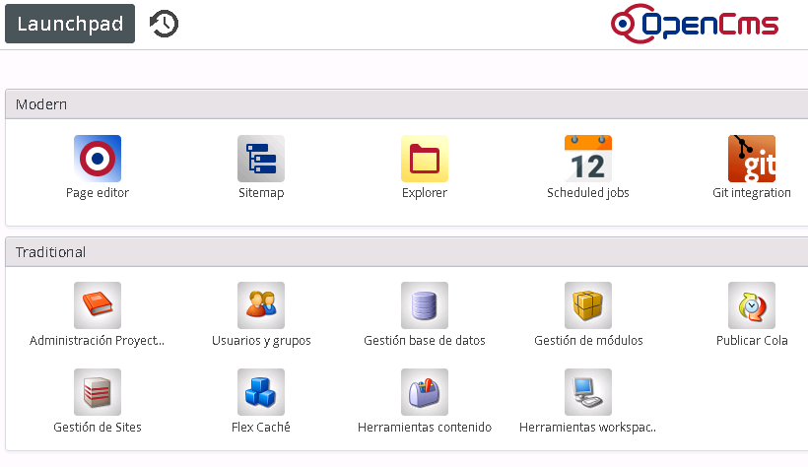

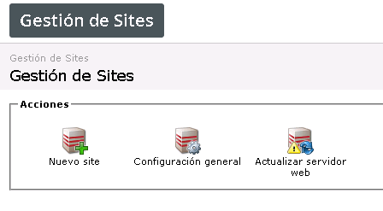

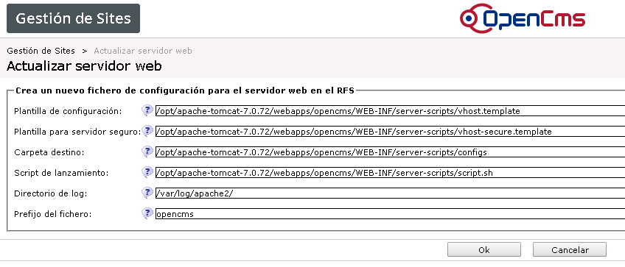

OpenCms genera en **/opt/apache-tomcat-7.0.72/webapps/opencms/WEB-INF/server-scripts/configs** los virtual host para cada site.

### Configurar Apache para que lea los VH generados:

1. Aseguramos los permisos de ejecución para el fichero **/opt/apache-tomcat-7.0.72/webapps/opencms/WEB-INF/server-scripts/**

sudo chmod 777 script.sh

1. En Apache añadimos un link a la carpeta de generación de virtual host de OpenCms:

cd /etc/httpd/conf.d/ sudo ln -s /opt/tomcat/webapps/opencms10/WEB-INF/server-scripts/configs/

1. Editamos el fichero **httpd.conf**

sudo nano /etc/httpd/conf/httpd.conf

Añadiendo la línea:

# Include the opencms virtual host:

IncludeOptional /etc/httpd/conf.d/configs/opencms*

# Permisos

Es necesario que Apache tenga permiso de lectura sobre los ficheros contenidos en **webapps/opencms/**

1. Sustituir por el dominio de las palmas
2. Sustituir por el dominio de las palmas
3. Sustituir por el correo de administrador
4. Sustituir con el nombre del dominio access_dominio.log
5. Sustituir con el nombre del dominio error_dominio.log
6. Sustituir por el dominio
7. El atributo server debe ser el subdominio del site